Chapter 6, Solution 45.

If the voltage waveform in Fig. 6.68 is applied to a 10-mH inductor, find the inductor current i(t) for 0 < t < 2 s. Assume i(0) = 0.

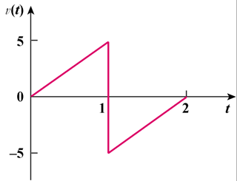

Figure 6.68
For Prob. 6.45.

Solution

i(t) =

For 0 < t < 1, v = 5t

dt + 0

= 250t² A

For 1 < t < 2, v = -10 + 5t

= [1 – t + 0.25t² ] kA

